Elford Neighbourhood Plan Residents’ Survey
May 2016

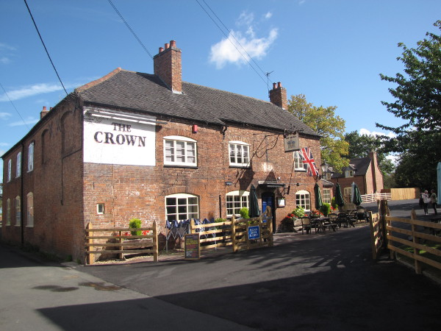 | 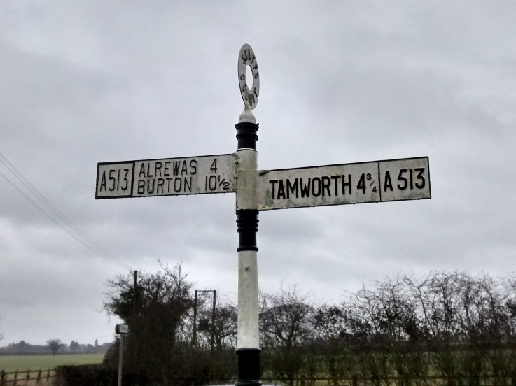
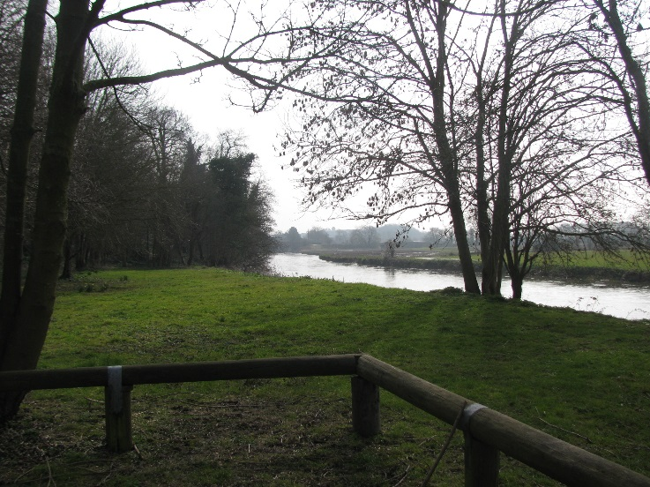 | 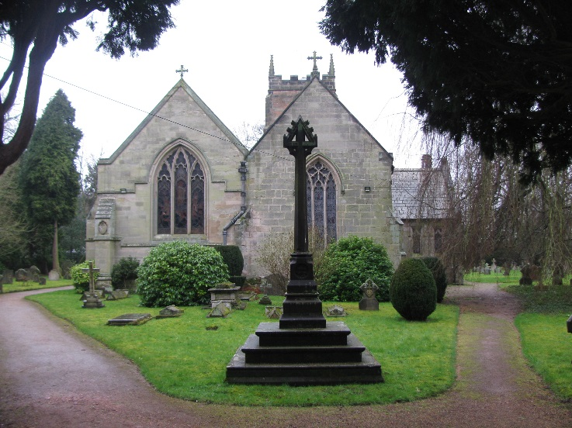
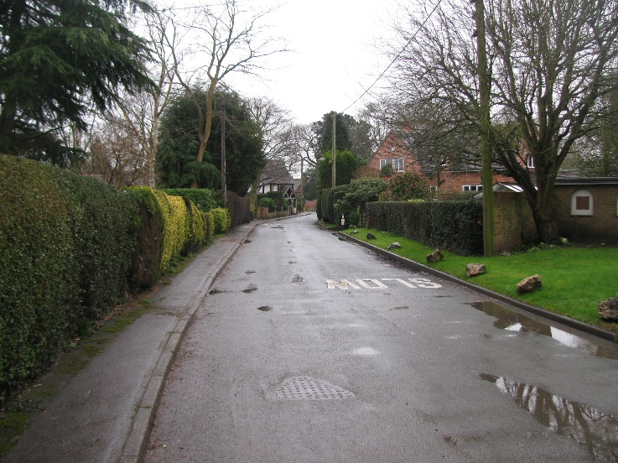 | 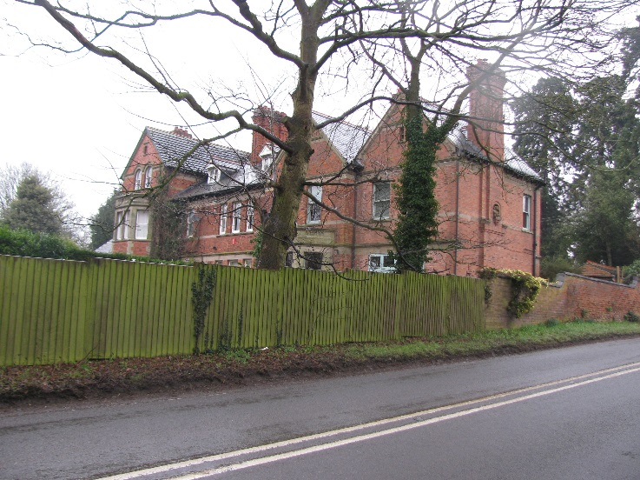

Elford Neighbourhood Plan Steering Group
This survey has been distributed to all households in Elford Parish to seek the views, comments and suggestions of residents on a range of local issues.
Feedback received will be used to steer the preparation of the Elford Neighbourhood Plan, which is intended to guide the future development of the parish. The neighbourhood plan steering group believe that a plan for the parish may help to address some of the issues that the local community are concerned about, including protecting and improving local facilities (like the school and the pub), securing the viability of the community by making sure families can continue to live here, the character of the village, quality of life, and the natural environment. This survey asks your views on these issues. A few technical terms are explained on the last page of the survey, and there are maps of the Parish and the Conservation Area at the back.
More details about the neighbourhood plan can be found on the Parish Council’s website www.elfordparish.co.uk or by contacting the Parish Clerk on 01827 50230.
Anyone from secondary school age and older is welcome to share their views. We have distributed one survey to each household, but if members of your household want to respond separately, we can provide additional copies – please get in touch, or download the survey from the Parish Council website.
Please return your completed survey forms to the Parish Council postbox next to the notice board at the Village Hall, or by post to M.Jones, Clerk to Elford PC, 50 Cornwall Avenue, Tamworth, B78 3YB.
You can scan and email your completed survey to clerk@elfordpc.co.uk. Or, if you prefer to complete the survey on your computer, just download the Microsoft Word version from the Parish Council website and email it to us once completed.
Please return your completed survey no later than Monday 13th June 2016.

Key facts about Elford: Did you know…?
- Elford is home to about 630 people, living in around 250 households.
- Between the 2001 and 2011 censuses, the population grew by about 9%, slightly faster than the average for England.
- In this time, the working age proportion of the population declined by about 5%, and the proportion of residents over the age of 65 grew by 4.5%, in line with the national average.
- Howard Primary School currently has 53 pupils, of which about half live in Elford, with a total capacity of about 80.
- Much of the built-up area of Elford is part of a Conservation Area. The Conservation Area has recently been widened from its original extent, to include more of the village’s buildings.
- There are 29 listed buildings in Elford. Parts of the Church of St Peter date from Medieval times, though the Church was mostly rebuilt in the mid-19th century and there are several buildings which are much earlier than this.
- Elford has a much higher proportion of owner-occupied homes than the national average – 84% compared to 64%. Elford has much lower provision of social housing than the national average – 8% of homes compared to about 18%.

- About you
Please provide any of the following personal details so that we can make sure that the views of all parts of our community are included. This is optional, but we would be very grateful for any information you are comfortable to provide. All personal information will be treated confidentially and won’t be shared beyond the Parish Council, the neighbourhood plan steering group, and our planning advisors BPUD Ltd.
  - Name
- Postcode |  |  |  |  |  |  | - Gender
  - Your age (please tick)
11-16 | 17-21 | 22-30 |  | 31-40 |  | 41-50 |  | 51-65 | 66-75 | 75+ | Prefer not to say
  - Are you completing this survey for: (Please tick one)
Yourself as an individual? |  |  |  |  | On behalf of your whole household?

- Local Services

  - Existing services and facilities
How important are each of these existing local services and facilities to you, on a scale of 1 to 5?
 |  | 1  (Not at all) | 2 | 3 | 4 | 5  (Very)
The Crown pub
Village Hall
Howard Primary School
St Peter’s Church
Walled Garden
Sports and Social Club
Football Field
Cricket Club
Playground
Picnic Area
Others (Please specify)
Do you think any of these facilities should be improved or expanded? Please specify how.

  - Services outside the village: Do you find it difficult to access any of the following services? (Please tick all that apply).
Doctors (GP) | Chemist | Optician | Dentist | Vet
Convenience shopping | Supermarket/ weekly shop | Public transport connections | Regular Post Office services | Banking
Other (please specify)

  - Improving services and facilities
How important do you think it is to provide, improve, or support the following services and facilities in Elford?
 |  | 1  (Not at all) | 2 | 3 | 4 | 5  (Very)
More bus routes and more frequent services
A village shop
Car parking for the school/cricket ground/football field/church
Increase capacity of the primary school
Cycle routes and facilities
Improve footpath provision and the pedestrian environment
Manage and promote village facilities
Encourage visitors to the village
Broadband speed
Solar energy
Wind energy
Other renewable energy sources (e.g. biomass, ground source heat)
Mains gas
Social and leisure opportunities for older people
Social and leisure opportunities for teenagers and young adults
Play provision for children
Allotments
Improvement and promotion of the walled garden
Café / coffee shop
Mobile library
Milk delivery
Are there any other services or facilities that you think should be provided in Elford? Please specify

  - How many of your children (if any) attend Howard Primary School?
I don’t have children | None (my children attend a different primary school) | None (my children aren’t of primary school age) | 1 | 2 | 3 | 4+

  - If your children attend a different primary school, please state why this is.

  - How concerned are you about the viability of the school, on a scale of 1 to 5?
1 (Not at all) | 2 | 3 | 4 | 5 (Very)

- Housing
Your home and household today
  - Tenure
Please tick to indicate your current tenure type:

Private rented |  | Social rented
Owned |  | Shared-ownership affordable
Living with family (e.g. parent’s home)
Other (please describe)

  - Type of dwelling
Please tick to indicate the type of home you currently live in:
Flat/Studio | Bungalow | House | Sheltered accommodation / retirement home
Other (please describe)

  - Size of home
Please tick to indicate the size of your current home:
1 bedrooms | 2 bedrooms | 3 bedrooms | 4+ bedrooms

  - Your household
Please indicate the size and composition of your household (everybody living with you at home, including university students currently away) by noting the number of people in each age group that live with you:
Age | 0-5 | 6-11 | 12-18 | 18-25 | 26-40 | 41-60 | 61-75 | 75+ | Total
Number

Your housing needs in the future
  - Do you think you will remain living in Elford for at least the next ten years?

Yes |  |  | If not, please give your reasons in the space below
No

If you answered yes to the above question, what do you think your housing needs will be ten years from now?

  - Tenure (please tick)

Private rented |  | Social rented
Owned |  | Shared-ownership affordable
Living with family (e.g. parent’s home)
Other (please describe)

  - Type of dwelling (please tick)
Starter home | Larger family home | Flat | Bungalow | Sheltered accommodation or retirement home | Retirement/downsizing home
Other (please describe)

  - Dwelling size (please tick)
1 bedroom | 2 bedrooms | 3 bedrooms | 4+ bedrooms

Your children’s future housing needs.
If you have children who currently live with you, and you think they may want to remain in the village over the next ten years, what housing do you think they may require? (Please tick all that may apply in this time period)
  - Tenure
Private rented |  | Social rented
Owned |  | Shared-ownership affordable
Still living with family (e.g. parent’s home) |  | I do not have children living with me
Other (please describe)

  - Type of dwelling
Starter home | Larger family home | Flat | Bungalow
Other (please describe)

  - Dwelling Size
1 bedroom | 2 bedrooms | 3 bedrooms | 4+ bedrooms

  - Other housing needs in Elford
Apart from your own housing needs and those of your immediate family, what other types of additional accommodation do you think may be needed in Elford over the next 10 years? (Please tick as many as you think). It may be useful to know that a proportion of affordable housing is normally expected on developments of 10 or more homes.
1-2 bed starter homes (owned) | 3-4 bed family houses (owned) | 5+ bed houses (owned) | 1-2 bed flats
Bungalows | Social rented homes | Private rented homes | Retirement homes and sheltered accommodation
Please explain your view/Suggest other types of homes

There are currently around 250 homes in the village. Lichfield DC’s Local Plan has not allocated any new housing in Elford. This means that the planning system at present does not propose any significant new residential development in the village. The neighbourhood plan could propose that more housing should be developed, if this is what the community want. Alternatively, the neighbourhood plan could simply provide guidance on types and design for the small numbers of houses that might otherwise be built.

  - Do you think that any additional new houses should be built in Elford? (Please tick)

Yes |  |  | Please give your reasons for your answer, in the space below
No

  - If you answered yes to the above question, how many new homes do you think should be built in Elford over the next 10 years? (Please tick)
1-5 | 6-10 | 11-15 | 16-20 | 21-25 | 26-35 | 35-50 | More

- Building design, local character and heritage

  - Character and village environment
How important (1-5) do you think each of the following are to maintaining and improving quality of life in Elford?
 | 1  (Not at all) | 2 | 3 | 4 | 5  (Very)
The relatively small size of the village
The rural and historic character of the village / Protecting the character of the conservation area
Protecting the open countryside around the village.
Community spirit, community activities and groups
Improve signposting for visitors, walkers and cyclists
Widening the Conservation Area further
More benches around the village
Preservation of the church and monuments
Other improvements to the character and environment of the village? Please specify.
Please note your favourite buildings and areas of the village, which you think are examples of good building design. Alternatively, are there particular architectural styles that you think could be avoided in the village?

- The natural environment and the rural economy

The natural environment
  - How important do you think the following natural environment considerations are in Elford, on a scale of 1 to 5?
 | 1  (Not at all) | 2 | 3 | 4 | 5  (Very)
Flood risk in the village
Protect existing open spaces
Create more wildlife friendly areas
Protect important views of the village and of the surrounding countryside
Create new areas of trees, shrubs, flowerbeds
Other environmental issues or improvements? Please specify.
Please note what you consider to be the most important open spaces and views in and out of the village

The rural economy
  - In your opinion, how important are the following issues and aspirations, related to the rural economy?
 | 1  (Not at all) | 2 | 3 | 4 | 5  (Very)
The effects on residents of non-agricultural activities on farmland around Elford
Restricting economic activity in the surrounding farming landscape to agricultural operations
Preserving farmland for sustainable agricultural use
Achieving a reasonable balance of the needs of agricultural businesses and the quality of life of residents and other businesses

  - Do you run or own a business in Elford? (please tick)

Yes |  |  | Please give any comments on your experience of this issue
No

  - If so, what kind of business? (please tick)
Office / professional service
Internet-based
Workshop
Agricultural
Health and beauty
Other (please specify)

  - How important do you think it is to provide better employment opportunities in Elford? (Please tick)
1 (Not at all) | 2 | 3 | 4 | 5 (Very)

  - Do you think there is a need for additional business premises in Elford? (Please tick)
Yes
No

  - If so, what type? (Please tick)
Offices
Workshops
Retail
Other types / Please add your thoughts on this issue

- Managing new development

  - How important do you think the following issues are, relating to potential new development in Elford? (Please tick)
 | 1  (Not at all) | 2 | 3 | 4 | 5  (Very)
Speed of traffic within the village
Speed of traffic on roads into and around Elford
Encouraging sustainable forms of transport (bus, cycling, walking)
Volume of cars passing through the village
Movement of lorries and heavy goods vehicles in the village
Highway safety on narrow roads e.g. Church Road, Brickhouse Lane
Parking at the Primary School
Parking at the Sports and Social Club
The no-through road (Church Road/Brickhouse Lane)
Other impacts of development (please specify)

- Other issues

  - Please use the space below to add your comments about:
- Any of the above issues or any other issues which you think should be addressed by the plan
- About the suggestion of a neighbourhood plan for Elford generally – do you think it’s a good idea at all?

Key terms explained
Shared-ownership affordable: A home that the occupant is able to buy a share of (25% to 75% of the home’s value), and they pay rent on the remaining share. | Social rented: A home owned by a local authority or private registered provider, rented out at no more than 80% of the local private market rent.
Private rented: A home rented from a private owner | Starter home: A house that is intended in design and price to be for a first time buyer.
Sheltered accommodation: Self-contained flats with some shared facilities, specifically designed for the elderly or disabled.

Thank you for taking the time to complete this survey. Please return your survey by Monday 13th June, following the instructions on the front page.
Your responses will be crucial to ensuring that the objectives and policies of Elford’s neighbourhood plan fully reflects residents’ concerns and hopes for the future of our village.

